Software Requirements Specification

for

ATM Management System

Version 1.0 approved

Ramit Bose(21BCE1316) and Gourav Ghosh(21BCE5513)

VIT, Chennai

10/02/2023

Table of Contents

Table of Contents ii

Revision History ii

1. Introduction 1

1.1 Purpose 1

1.2 Document Conventions 1

1.3 Intended Audience and Reading Suggestions 1

1.4 Product Scope 1

1.5 References 1

2. Overall Description 2

2.1 Product Perspective 2

2.2 Product Functions 2

2.3 User Classes and Characteristics 2

2.4 Operating Environment 2

2.5 Design and Implementation Constraints 2

2.6 User Documentation 2

2.7 Assumptions and Dependencies 3

3. External Interface Requirements 3

3.1 User Interfaces 3

3.2 Hardware Interfaces 3

3.3 Software Interfaces 3

3.4 Communications Interfaces 3

4. System Features 4

4.1 System Feature 1 4

4.2 System Feature 2 (and so on) 4

5. Other Nonfunctional Requirements 4

5.1 Performance Requirements 4

5.2 Safety Requirements 5

5.3 Security Requirements 5

5.4 Software Quality Attributes 5

5.5 Business Rules 5

6. Other Requirements 5

Appendix A: Glossary 5

Appendix B: Analysis Models 5

Appendix C: To Be Determined List 6

Revision History

|  |  |  |  |
| --- | --- | --- | --- |
| **Name** | **Date** | **Reason For Changes** | **Version** |
|  |  |  |  |
|  |  |  |  |

# Introduction

## Purpose

The purpose of the Automated Teller Machine (ATM) Management System is to provide a secure and efficient platform for customers to access their bank accounts and perform various financial transactions through an ATM machine. The system should be able to manage the dispensing of cash, deposit transactions, balance inquiries, and other related transactions.

The main objectives of the ATM Management System are:

* To provide a secure and user-friendly interface for customers to access their bank accounts and perform transactions through the ATM machine.
* To ensure efficient cash management, including dispensing of cash and tracking of cash levels in the machine.
* To provide real-time monitoring and tracking of all transactions performed through the ATM machine, for audit and security purposes.
* To support various types of transactions, such as cash withdrawals, balance inquiries, fund transfers, bill payments, and others.
* To provide an efficient system for bank employees to manage and maintain the ATM machine, including software upgrades, maintenance, and troubleshooting.
* To ensure high levels of reliability, availability, and scalability, to meet the growing demands of customers and the bank's operations.

## Document Conventions

* Terminology: Standard terms and definitions used in the banking and ATM industry are used throughout the document. Any specific terms or definitions used in the document are clearly defined and explained.
* Formatting: The document is divided into sections and subsections for ease of navigation and clarity. Headings and subheadings are clearly labeled and used consistently throughout the document.
* Diagrams and Figures: Diagrams, flowcharts, and other visual aids are used to help explain complex processes and interactions between different components of the system. Figures are clearly labeled and referenced in the text.
* Acronyms: Acronyms and abbreviations used in the document are defined the first time they are used, and a list of all acronyms used in the document is provided in an appendix.
* References: Any references to external documents, standards, or guidelines are clearly indicated in the text and listed in a reference section at the end of the document.
* Revision History: A revision history section is provided to track changes to the document over time, including the date of each revision, a description of the changes made, and the names of the individuals responsible for the changes.
* Page Numbers: Page numbers are provided for easy navigation of the document.
* Glossary: A glossary of terms and definitions used in the document is provided in an appendix.

By adhering to these conventions, the SRS document for the ATM Management System will be organized, clear, and easy to understand, helping to ensure that the system is developed according to the requirements and expectations of the stakeholders.

## Intended Audience and Reading Suggestions

* Project Manager: This person is responsible for overseeing the overall development of the system, and will use the SRS document to understand the requirements and scope of the project.
* Development Team: This group of individuals will use the SRS document to understand the technical requirements and specifications of the system, and to guide their development efforts.
* Quality Assurance Team: This group will use the SRS document to understand the functional and performance requirements of the system, and to develop and execute test cases to ensure that the system meets these requirements.
* Business Stakeholders: This group of individuals, including managers, business analysts, and other representatives from the bank and its customers, will use the SRS document to understand the business requirements and goals of the system.
* End Users: This group of individuals, including bank customers, will ultimately use the ATM machine and will be impacted by the system.

Reading Suggestions:

* Project Manager: It is recommended that the project manager thoroughly review the entire SRS document, paying special attention to the scope and objectives of the project, the functional and performance requirements of the system, and the high-level design of the system.
* Development Team: The development team should review the technical requirements and specifications of the system, including the hardware and software requirements, interface specifications, and security requirements.
* Quality Assurance Team: The quality assurance team should review the functional and performance requirements of the system, including the acceptance criteria and the system's expected behavior in different scenarios.
* Business Stakeholders: Business stakeholders should review the business requirements and goals of the system, including the requirements for the types of transactions that will be supported and the security and compliance requirements.
* End Users: End users should review the user interface and user experience requirements of the system, to understand how the ATM machine will be used and what they can expect when they interact with the machine.

By following these reading suggestions, each stakeholder will be able to understand their specific responsibilities and requirements related to the development and implementation of the ATM Management System.

## Product Scope

* Transaction Types: The system will support various types of transactions, including cash withdrawals, balance inquiries, fund transfers, bill payments, and others. The specific transactions that will be supported by the system will be clearly defined in the SRS document.
* User Management: The system will provide a secure and user-friendly interface for customers to access their bank accounts and perform transactions through the ATM machine. The system will also provide tools for bank employees to manage customer accounts and access levels.
* Cash Management: The system will ensure efficient cash management, including dispensing of cash and tracking of cash levels in the machine. The system will also provide a mechanism for bank employees to refill the cash in the machine as needed.
* Transaction Monitoring: The system will provide real-time monitoring and tracking of all transactions performed through the ATM machine, for audit and security purposes. The system will also provide reports and analytics to help the bank understand usage patterns and identify potential issues.
* Maintenance and Support: The system will provide an efficient system for bank employees to manage and maintain the ATM machine, including software upgrades, maintenance, and troubleshooting.
* Compliance and Security: The system will comply with all relevant banking regulations and industry standards, and will provide high levels of security for customer information and transactions.

The product scope for the ATM Management System is defined to provide a comprehensive and integrated platform for customers to access their bank accounts and perform financial transactions through an ATM machine, while also providing tools for bank employees to manage and maintain the system. By clearly defining the product scope in the SRS document, the development team will have a clear understanding of the requirements and goals of the project, and the stakeholders will have a clear understanding of what the system will and will not deliver.

## References

The references section should include, but is not limited to, the following items:

* Banking regulations: The SRS document should reference the relevant banking regulations, such as the Bank Secrecy Act (BSA) and the Anti-Money Laundering (AML) regulations, that will apply to the ATM Management System.
* Industry standards: The SRS document should reference relevant industry standards, such as the Payment Card Industry Data Security Standard (PCI DSS) and the ISO 8583 standard for financial transactions, that will apply to the system.
* Technical standards: The SRS document should reference relevant technical standards, such as the ISO 27001 standard for information security management, that will apply to the system.
* Product specifications: The SRS document should reference any relevant product specifications, such as the specifications for the ATM machine hardware and software, that will be used in the development of the system.
* Other project documents: The SRS document should reference any other relevant project documents, such as the project charter, the project plan, and the test plan, that will be used in the development and implementation of the system.

By including references in the SRS document, the development team will have a clear understanding of the context and requirements for the project, and stakeholders will be able to easily find additional information about the project as needed. Additionally, including references in the SRS document will help ensure that the development of the ATM Management System is informed by industry best practices and relevant regulations and standards.

# Overall Description

## Product Perspective

* Purpose: A description of the purpose of the ATM Management System and how it will meet the needs of the organization and its customers.
* Product Overview: A high-level description of the features and capabilities of the ATM Management System, including the types of transactions that will be supported, the user management features, the cash management features, the transaction monitoring features, and the maintenance and support features.
* User Interfaces: A description of the user interfaces that will be provided by the system, including the customer-facing interface for performing transactions and the back-end interface for bank employees to manage and maintain the system.
* Relationships to Other Products: A description of the relationships between the ATM Management System and other products and systems that will be used in conjunction with the system, such as the bank's core banking system, the ATM machine hardware, and other related systems.
* Product Functionality: A description of the functional requirements that will be met by the ATM Management System, including the transactions that will be supported, the user management features, the cash management features, the transaction monitoring features, and the maintenance and support features.

By providing a product perspective in the SRS document, the development team and stakeholders will have a clear understanding of the product and its context, and will be able to make informed decisions about the development and implementation of the system. Additionally, the product perspective section of the SRS document will help ensure that the development of the ATM Management System is aligned with the needs and goals of the organization and its customers.

## Product Functions

* Customer Transactions: A description of the types of transactions that customers will be able to perform using the ATM, including cash withdrawals, balance inquiries, and deposits.
* User Management: A description of the user management features of the system, including the creation and maintenance of customer accounts, the management of user access rights, and the management of customer information and transaction history.
* Cash Management: A description of the cash management features of the system, including the management of cash levels in the ATM, the tracking of cash transactions, and the reconciliation of cash levels with the bank's records.
* Transaction Monitoring: A description of the transaction monitoring features of the system, including the detection of suspicious transactions, the generation of alerts and reports, and the management of disputes and fraud incidents.
* Maintenance and Support: A description of the maintenance and support features of the system, including the management of software updates, the management of hardware maintenance, and the management of customer support and service requests.
* Integration with Other Systems: A description of the integration between the ATM Management System and other systems that will be used in conjunction with the system, such as the bank's core banking system, the ATM machine hardware, and other related systems.

By providing a detailed description of the product functions in the SRS document, the development team and stakeholders will have a clear understanding of the functionality that the system will provide, and will be able to make informed decisions about the development and implementation of the system. Additionally, the product functions section of the SRS document will help ensure that the development of the ATM Management System meets the needs and goals of the organization and its customers.

## User Classes and Characteristics

* Customer Users: A description of the customers who will use the ATM to perform transactions, including their roles, responsibilities, and requirements.
* Bank Employees: A description of the bank employees who will use the back-end interface of the system to manage and maintain the system, including their roles, responsibilities, and requirements.
* Technical Support Personnel: A description of the technical support personnel who will be responsible for providing maintenance and support for the system, including their roles, responsibilities, and requirements.
* User Characteristics: A description of the specific characteristics of each user class, including their technical expertise, their level of experience with ATMs and other banking systems, and their accessibility needs (e.g., support for users with disabilities).

By providing a detailed description of the user classes and their characteristics in the SRS document, the development team and stakeholders will have a clear understanding of the needs and requirements of the different types of users who will interact with the system. This information will help to ensure that the development of the ATM Management System meets the needs of all users, and will also help to inform the design and implementation of the user interfaces and features of the system.

## Operating Environment

* Physical Environment: A description of the physical environment in which the ATM machines will be located, including information about the climate, temperature, humidity, and other environmental factors that may impact the operation of the system.
* Technical Environment: A description of the technical environment in which the system will operate, including information about the hardware, software, and network infrastructure that will be required to run the system. This should include information about the minimum and recommended hardware specifications, the supported operating systems, and the network protocols and standards that will be used.
* Data Management Requirements: A description of the data management requirements of the system, including information about the data storage and retrieval requirements, the data backup and recovery requirements, and the data security requirements.
* System Interfaces: A description of the interfaces between the ATM Management System and other systems that will be used in conjunction with the system, including information about the data exchange and integration requirements between the systems.

By providing a detailed description of the operating environment in the SRS document, the development team and stakeholders will have a clear understanding of the physical and technical environment in which the system will operate. This information will help to ensure that the development and implementation of the ATM Management System meets the technical requirements of the organization and its customers, and will also help to inform the design and implementation of the system components and interfaces.

## Design and Implementation Constraints

* Technical Constraints: A description of any technical limitations or constraints that will impact the design and implementation of the system, including information about the technology platforms, hardware and software specifications, and network infrastructure that must be used.
* Regulatory Constraints: A description of any regulatory requirements or constraints that will impact the design and implementation of the system, including information about industry standards and regulations, data privacy laws, and security requirements.
* Performance Constraints: A description of any performance constraints that will impact the design and implementation of the system, including information about the minimum response time requirements, the maximum number of transactions that can be processed per second, and the availability requirements for the system.
* Cost Constraints: A description of any cost constraints that will impact the design and implementation of the system, including information about budget limitations, resource constraints, and the costs associated with maintaining and supporting the system.

By providing a detailed description of the design and implementation constraints in the SRS document, the development team and stakeholders will have a clear understanding of the limitations and constraints that must be taken into account when designing and implementing the system. This information will help to ensure that the development and implementation of the ATM Management System meets the requirements of the organization and its customers, while also taking into account any technical, regulatory, performance, or cost constraints.

## User Documentation

* User Manual: A description of the user manual that will be provided to users of the system, including information about the contents of the manual, the format of the manual (e.g. online, print, etc.), and the target audience for the manual. The user manual should provide detailed information about how to use the system, including information about the user interface, the available features and functions, and the steps to perform common tasks.
* Quick Start Guide: A description of the quick start guide that will be provided to users of the system, including information about the contents of the guide, the format of the guide (e.g. online, print, etc.), and the target audience for the guide. The quick start guide should provide a concise overview of the system, including information about how to log in, how to perform basic tasks, and how to get help if needed.
* Help and Support Documentation: A description of the help and support documentation that will be provided to users of the system, including information about the contents of the documentation, the format of the documentation (e.g. online, print, etc.), and the target audience for the documentation. The help and support documentation should provide detailed information about how to get help with the system, including information about the support options that are available (e.g. online chat, email, phone, etc.), the hours of support, and the response time for support requests.

By providing detailed information about the user documentation in the SRS document, the development team and stakeholders will have a clear understanding of the user support that will be provided for the system. This information will help to ensure that the users of the ATM Management System have the information and resources they need to effectively use the system and to get help when needed.

## Assumptions and Dependencies

* Assumptions: A description of any assumptions that have been made about the system, including information about the user environment, the regulatory environment, and the technical environment. This information should include details about the available technology platforms, the available hardware and software specifications, and the network infrastructure that will be used.
* Dependencies: A description of any dependencies that the system has on other systems or components, including information about any external systems that the ATM Management System must interact with, any software libraries or tools that the system will use, and any other components that are required for the system to function.

By providing a detailed description of the assumptions and dependencies in the SRS document, the development team and stakeholders will have a clear understanding of the factors that will impact the development and implementation of the system. This information will help to ensure that the development and implementation of the ATM Management System is carried out in an efficient and effective manner, taking into account any external factors that may impact the project.

# External Interface Requirements

## User Interfaces

* Introduction:

This section provides an overview of the ATM Management System user interfaces and their purpose. The ATM Management System is designed to allow bank employees to manage and monitor the activities of ATMs, including cash management, account management, and security management.

* User Interfaces:

The ATM Management System has two main user interfaces, the Administrator Interface and the Customer Interface.

* Administrator Interface:

The Administrator Interface is a web-based interface that provides access to the management and monitoring functions of the ATM system. The interface is designed to be user-friendly and intuitive, allowing bank employees to easily manage and monitor the ATM system. The following are the features of the Administrator Interface:

a) Login Screen:

The login screen is the first screen that the user sees when accessing the Administrator Interface. It requires the user to enter a username and password to access the interface.

b) Dashboard:

The dashboard is the main screen that the user sees after logging in. It displays a summary of the status of the ATM system, including the number of ATMs, the amount of cash in each ATM, and the number of transactions performed.

c) ATM Management:

This section allows the user to add, edit, and delete ATMs from the system. The user can also view the details of each ATM, including its location, cash balance, and transaction history.

d) Account Management:

This section allows the user to add, edit, and delete customer accounts. The user can also view the details of each account, including the account balance and transaction history.

e) Cash Management:

This section allows the user to manage the cash in the ATMs, including adding and removing cash, as well as monitoring the cash balance of each ATM.

f) Security Management:

This section allows the user to manage the security of the ATM system, including setting and managing security alerts, as well as monitoring the security status of each ATM.

* Customer Interface:

The Customer Interface is a touch screen interface that is installed on each ATM. The interface is designed to be user-friendly and intuitive, allowing customers to easily perform transactions using the ATM. The following are the features of the Customer Interface:

a) Welcome Screen:

The welcome screen is the first screen that the customer sees when accessing the Customer Interface. It provides the customer with options to perform transactions, such as withdrawing cash, checking their account balance, and making deposits.

b) Transaction Screen:

The transaction screen allows the customer to perform transactions, such as withdrawing cash, checking their account balance, and making deposits.

c) Account Management:

This section allows the customer to manage their account, including viewing their account balance and transaction history.

d) Security:

This section allows the customer to manage the security of their account, including setting and changing their password, as well as reporting any security incidents.

* Conclusion:

The ATM Management System user interfaces are designed to provide bank employees and customers with a user-friendly and intuitive way to manage and perform transactions using ATMs. The Administrator Interface provides access to the management and monitoring functions of the ATM system, while the Customer Interface provides a touch screen interface for customers to perform transactions using the ATM.

## Hardware Interfaces

* Introduction:

This section provides an overview of the ATM Management System hardware interfaces and their purpose. The ATM Management System is designed to allow bank employees to manage and monitor the activities of ATMs, including cash management, account management, and security management.

* Hardware Interfaces:

The ATM Management System requires the following hardware components to function:

a) ATM Terminal:

The ATM terminal is the physical machine that customers interact with to perform transactions. It is equipped with a touch screen interface, card reader, cash dispenser, and receipt printer.

b) Network Connectivity:

The ATM terminal is connected to the bank's network, allowing it to communicate with the ATM Management System. This connection is used for sending and receiving transaction data, as well as for monitoring the status of the ATM.

c) Cash Dispenser:

The cash dispenser is a mechanical component that dispenses cash to the customer. It is connected to the ATM terminal and communicates with the ATM Management System to monitor the cash balance and perform cash dispensing operations.

d) Card Reader:

The card reader is a mechanical component that reads the customer's card information. It is connected to the ATM terminal and communicates with the ATM Management System to validate the customer's account information and perform transactions.

e) Receipt Printer:

The receipt printer is a mechanical component that prints receipts for transactions performed using the ATM. It is connected to the ATM terminal and communicates with the ATM Management System to print receipts for transactions.

* Integration with Bank's Infrastructure:

The ATM Management System must be integrated with the bank's existing infrastructure, including the bank's network, security systems, and data centers. This integration allows the ATM Management System to access the bank's customer data and perform transactions, as well as ensuring the security and reliability of the system.

* Security:

The hardware components of the ATM Management System must be designed and implemented with security in mind. This includes implementing secure protocols for communication between the hardware components and the ATM Management System, as well as ensuring the physical security of the components.

* Conclusion:

The hardware components of the ATM Management System are an essential part of the system, providing the physical interface for customers to perform transactions and for bank employees to manage and monitor the ATM system. The hardware components must be designed and implemented with security in mind to ensure the reliability and security of the system.

## Software Interfaces

* Introduction:

This section provides an overview of the software interfaces for the ATM Management System and their purpose. The ATM Management System is designed to allow bank employees to manage and monitor the activities of ATMs, including cash management, account management, and security management.

* Software Interfaces:

The ATM Management System requires the following software components to function:

a) ATM Management System Software:

This is the core component of the ATM Management System, responsible for managing and monitoring the activities of the ATMs. It provides an interface for bank employees to perform administrative tasks, such as managing ATM cash levels, managing customer accounts, and monitoring security events.

b) ATM Terminal Software:

This software component is installed on each ATM terminal and is responsible for communicating with the ATM Management System to perform transactions and provide status information.

c) Database Management System:

The ATM Management System requires a database to store customer data, transaction data, and ATM status information. This component is responsible for managing and storing the data in a secure and reliable manner.

d) Network Management System:

This component is responsible for managing the network connection between the ATM terminals and the ATM Management System. It ensures that data is transmitted securely and reliably, and provides status information on the network connection.

e) Security Management System: The Security Management System is responsible for ensuring the security of the ATM Management System, including protection against unauthorized access, data theft, and other security threats.

* Integration with Bank's Infrastructure:

The ATM Management System must be integrated with the bank's existing infrastructure, including the bank's network, security systems, and data centers. This integration allows the ATM Management System to access the bank's customer data and perform transactions, as well as ensuring the security and reliability of the system.

* User Interfaces:

The ATM Management System provides the following user interfaces for bank employees:

a) Administration Interface:

This interface is used by bank employees to perform administrative tasks, such as managing ATM cash levels, managing customer accounts, and monitoring security events. It is designed to be easy to use and provides access to the functionality required to perform these tasks.

b) Monitoring Interface:

This interface provides real-time information on the status of the ATM system, including the status of individual ATMs, network connectivity, and security events.

* Conclusion:

The software components of the ATM Management System are essential to the functioning of the system and provide the interface for bank employees to manage and monitor the ATM system. The software interfaces must be designed and implemented to ensure the security, reliability, and ease of use of the system.

## Communications Interfaces

* Introduction:

This section provides an overview of the communication interfaces for the ATM Management System and their purpose. The ATM Management System is designed to allow bank employees to manage and monitor the activities of ATMs, including cash management, account management, and security management.

* Communication Interfaces:

The ATM Management System requires the following communication interfaces to function:

a) ATM Terminal Interface:

The ATM terminal is the primary interface for communication between the ATM Management System and the customer. This interface allows customers to perform transactions, such as withdrawals and deposits, and provides the ATM Management System with information on the status of the ATM.

b) Network Interface:

The network interface is used for communication between the ATM terminals and the ATM Management System. It is responsible for transmitting transaction data, status information, and security data securely and reliably.

c) Database Interface:

The database interface is used for communication between the ATM Management System and the database management system. It is responsible for transmitting data to and from the database, as well as managing the storage of data in the database.

d) Security Interface:

The security interface is responsible for managing the communication of security data, including user authentication information and encryption keys, between the ATM Management System and the security management system.

* Integration with Bank's Infrastructure:

The ATM Management System must be integrated with the bank's existing infrastructure, including the bank's network, security systems, and data centers. This integration allows the ATM Management System to access the bank's customer data and perform transactions, as well as ensuring the security and reliability of the system.

* Communication Protocols:

The ATM Management System must support the following communication protocols:

a) TCP/IP:

The ATM Management System must support the Transmission Control Protocol/Internet Protocol (TCP/IP) for network communication.

b) SSL/TLS:

The ATM Management System must support the Secure Sockets Layer/Transport Layer Security (SSL/TLS) protocols for secure communication over the network.

c) Database Protocols:

The ATM Management System must support the database protocols required to communicate with the database management system.

* Conclusion: The communication interfaces and protocols of the ATM Management System are essential to the functioning of the system, providing the means for transmitting data securely and reliably between the various components of the system. The communication interfaces and protocols must be designed and implemented to ensure the security, reliability, and performance of the system.

# System Features

This section provides an overview of the system features of the ATM Management System, including the description, priority, stimulus/response time, and functional requirements for each system feature. The ATM Management System is designed to allow bank employees to manage and monitor the activities of ATMs, including cash management, account management, and security management.

## System Feature 1: Cash Management (High Priority)

4.1.1 Description and Priority

This feature allows bank employees to manage cash levels in ATMs and schedule cash replenishment.

4.1.2 Stimulus/Response Sequences

Cash levels in ATMs must be updated in real-time, with a response time of less than 1 second.

4.1.3 Functional Requirements

* Ability to view current cash levels in ATMs
* Ability to schedule cash replenishment for ATMs
* Real-time monitoring of cash levels in ATMs
* Ability to generate reports on cash management activities

## System Feature 2: Account Management (High Priority)

4.2.1 Description and Priority

This feature allows bank employees to manage customer accounts and transactions through ATMs.

4.2.2 Stimulus/Response Sequences

Customer transactions must be processed in real-time, with a response time of less than 5 seconds.

4.3.3 Functional Requirements

* Ability to view and manage customer account information
* Real-time monitoring of customer transactions
* Ability to suspend or deactivate accounts in case of fraud or security concerns
* Ability to generate reports on customer account activity

## System Feature 3: Security Management (High Priority)

4.3.1 Description and Priority

This feature provides a secure login and authentication system for bank employees and monitors ATM security.

4.3.2 Stimulus/Response Sequences

The login and authentication system must have a response time of less than 2 seconds.

4.3.3 Functional Requirements

* Secure login and authentication system for bank employees
* Real-time monitoring of ATM security
* Ability to control access to ATM functions based on user role and authorization levels
* Ability to generate reports on security activities and alerts

## System Feature 4: ATM Terminal Monitoring (Medium Priority)

4.4.1 Description and Priority

This feature provides real-time monitoring of ATM terminal status and allows bank employees to remotely troubleshoot and resolve issues with ATMs.

4.4.2 Stimulus/Response Sequences

The monitoring system must have a response time of less than 5 seconds.

4.4.3 Functional Requirements

* Real-time monitoring of ATM terminal status
* Ability to remotely troubleshoot and resolve issues with ATMs
* Ability to generate reports on ATM terminal issues and their resolution

## System Feature 5: Reporting and Analytics (Low Priority)

4.5.1 Description and Priority

This feature generates reports on ATM usage and transaction data and provides data analytics on ATM usage and customer behavior.

4.5.2 Stimulus/Response Sequences

Reports must be generated within a response time of less than 10 seconds.

4.5.3 Functional Requirements

* Ability to generate reports on ATM usage and transaction data
* Data analytics on ATM usage and customer behavior
* Ability to export reports in a variety of formats, including PDF and CSV

Conclusion: The system features of the ATM Management System are crucial to its functionality and provide the necessary tools for bank employees to manage and monitor ATM activities. The priority, stimulus/response time, and functional requirements for each system feature have been determined based on its importance to the system and its potential impact on the overall functionality of the system.

# Other Nonfunctional Requirements

## Performance Requirements

* System Availability: The ATM management system should have a minimum availability of 99.5% during regular operating hours and should provide continuous service with minimal downtime.
* Response Time: The system should respond to user requests within 3 seconds for basic transactions and within 5 seconds for more complex transactions.
* Transaction Processing Speed: The system should be able to process a minimum of 10 transactions per minute.
* Data Processing Capacity: The system should be able to handle a minimum of 100,000 transactions per day and store a minimum of 6 months of transaction data.
* User Authentication: The system should implement secure user authentication methods, such as PIN and biometric authentication, to ensure the safety of user information and transactions.
* Data Security: The system should comply with industry standard security protocols to protect sensitive information, such as bank account details and transaction records.
* Error Handling: The system should provide user-friendly error messages and log all errors for further analysis.
* Reporting and Analysis: The system should provide real-time reporting and analysis capabilities, including transaction reporting, user activity reporting, and error reporting.
* Scalability: The system should be designed to scale up or down in response to changing customer needs and usage patterns.
* Maintenance and Support: The system should include ongoing maintenance and support services, such as software updates and technical support.
* Interoperability: The system should be able to seamlessly integrate with other banking systems, such as core banking systems and mobile banking applications.

## Safety Requirements

* Physical Security: The ATM system should have measures in place to prevent unauthorized physical access to the ATM machine and its components, including the use of tamper-evident seals and security cameras.
* Network Security: The system should implement strong network security protocols, such as encryption and firewalls, to prevent unauthorized access to the ATM network and user information.
* Data Backup and Recovery: The system should have a robust backup and recovery plan in place to ensure that user data is protected and can be recovered in case of a disaster.
* Access Control: The system should implement strict access control measures to ensure that only authorized personnel have access to sensitive information and systems.
* Auditing and Monitoring: The system should include auditing and monitoring features to detect and prevent security breaches and to ensure compliance with security standards and regulations.
* Malware Protection: The system should be protected against malware attacks, such as viruses and trojans, by implementing up-to-date anti-virus software and security patches.
* Physical Tamper Detection: The system should have physical tamper detection capabilities to alert personnel of any physical tampering with the ATM machine.
* Emergency Response Plan: The system should have a well-defined emergency response plan in place to respond to security incidents, such as theft or data breaches, in a timely and effective manner.
* Compliance with Regulations: The system should comply with all relevant security and privacy regulations, such as PCI DSS and GDPR.
* User Awareness and Training: The system should include user awareness and training programs to educate users on best practices for ATM security and to raise awareness of potential security threats.

## Security Requirements

* Physical Security: The ATM system should have measures in place to prevent unauthorized physical access to the ATM machine and its components, including the use of tamper-evident seals and security cameras.
* Network Security: The system should implement strong network security protocols, such as encryption and firewalls, to prevent unauthorized access to the ATM network and user information.
* Data Backup and Recovery: The system should have a robust backup and recovery plan in place to ensure that user data is protected and can be recovered in case of a disaster.
* Access Control: The system should implement strict access control measures to ensure that only authorized personnel have access to sensitive information and systems.
* Auditing and Monitoring: The system should include auditing and monitoring features to detect and prevent security breaches and to ensure compliance with security standards and regulations.
* Malware Protection: The system should be protected against malware attacks, such as viruses and trojans, by implementing up-to-date anti-virus software and security patches.
* Physical Tamper Detection: The system should have physical tamper detection capabilities to alert personnel of any physical tampering with the ATM machine.
* Emergency Response Plan: The system should have a well-defined emergency response plan in place to respond to security incidents, such as theft or data breaches, in a timely and effective manner.
* Compliance with Regulations: The system should comply with all relevant security and privacy regulations, such as PCI DSS and GDPR.
* User Awareness and Training: The system should include user awareness and training programs to educate users on best practices for ATM security and to raise awareness of potential security threats.

## Software Quality Attributes

* Usability: The system should have a user-friendly interface that is easy to navigate and understand, and should provide clear and concise instructions for performing transactions.
* Reliability: The system should be designed to operate reliably, with minimal downtime and errors, and should provide accurate and consistent results.
* Performance: The system should be designed to perform efficiently, with fast response times and minimal delays, even under high user demand.
* Scalability: The system should be designed to scale up or down in response to changing customer needs and usage patterns.
* Maintainability: The system should be designed for ease of maintenance, with well-documented code and clear separation of responsibilities between components.
* Security: The system should implement strong security measures to protect user information and transactions, and to prevent unauthorized access to the system.
* Compatibility: The system should be compatible with relevant hardware and software platforms, and should support integration with other banking systems.
* Testability: The system should be designed for ease of testing, with well-defined test cases and clear test procedures.
* Portability: The system should be designed for ease of portability, with modular and flexible code that can be easily adapted to different environments.
* Interoperability: The system should be able to seamlessly integrate with other banking systems, such as core banking systems and mobile banking applications.

## Business Rules

* User Authentication: The system should require users to authenticate their identity using a valid ATM card and personal identification number (PIN) before performing transactions.
* Transaction Limits: The system should enforce transaction limits, such as daily withdrawal limits, to prevent fraud and to ensure the security of user funds.
* Dispensing Cash: The system should dispense cash only if the user has sufficient funds available in their account and the transaction is within their daily withdrawal limit.
* Account Balances: The system should provide users with accurate account balances and transaction history, and should reflect all deposits and withdrawals in a timely manner.
* Fund Transfers: The system should allow users to transfer funds between their own accounts or to other accounts, subject to any applicable transaction limits and security controls.
* Card Block: The system should block an ATM card if it is reported as lost or stolen, or if there are multiple failed attempts to enter the correct PIN.
* Receipt Printing: The system should provide users with a printed receipt for each transaction, listing the transaction details and the updated account balance.
* Error Handling: The system should handle errors and exceptions in a consistent and user-friendly manner, and should provide clear and concise error messages.
* Dispute Resolution: The system should provide a mechanism for users to resolve disputes or report errors, such as an ATM complaint hotline or an online dispute resolution system.
* Regulatory Compliance: The system should comply with all relevant laws, regulations, and industry standards, such as anti-money laundering regulations and data privacy laws.

# Other Requirements

* ATM Availability: The system should ensure that ATMs are available for use by customers at all times, with minimal downtime for maintenance or upgrades.
* ATM Network Management: The system should provide centralized management and monitoring of the ATM network, including the ability to remotely control and configure individual ATMs.
* Reporting and Analytics: The system should provide robust reporting and analytics capabilities, including transaction reports, performance reports, and customer usage patterns.
* Customer Support: The system should provide a range of customer support services, such as an ATM helpline, online support, and in-person support at banking branches.
* Multilingual Support: The system should support multiple languages, to accommodate customers who speak different languages and to provide a positive customer experience.
* Mobile Integration: The system should integrate with mobile banking applications, allowing users to perform transactions and manage their accounts from their mobile devices.
* Cash Management: The system should provide efficient and effective cash management capabilities, including cash replenishment and cash balancing.
* User Feedback and Suggestions: The system should provide a mechanism for users to provide feedback and suggestions, such as a customer feedback form or an online suggestion box.
* ATM Upgrades and Enhancements: The system should provide a framework for continuous improvement and enhancement of the ATM network, based on customer feedback and changing customer needs.
* Disaster Recovery and Business Continuity: The system should have a well-defined disaster recovery and business continuity plan in place to ensure that critical systems and services can be quickly restored in the event of a disaster.

Appendix A: Glossary

* ATM (Automated Teller Machine): A self-service electronic device that allows customers to perform financial transactions, such as withdrawals, deposits, and transfers, using a bank card and personal identification number (PIN).
* SRS (Software Requirements Specification): A detailed description of the functional and non-functional requirements for a software system, including performance, safety, security, and software quality attributes.
* User Authentication: The process of verifying a user's identity, typically by requiring the user to enter a valid ATM card and personal identification number (PIN).
* Transaction Limits: The maximum amount of money that a user can withdraw or transfer in a single transaction or within a given time period, as determined by the bank.
* Account Balances: The total amount of money available in a customer's account, including all deposits and available credit.
* Fund Transfers: The process of moving money from one account to another, either within the same bank or to a different bank.
* Card Block: The process of disabling an ATM card to prevent unauthorized use, typically due to loss, theft, or multiple incorrect PIN entries.
* Receipt Printing: The process of printing a detailed record of a transaction, including the transaction details and updated account balance.
* Error Handling: The process of managing and resolving errors or exceptions that occur during the use of a software system, typically by displaying clear and concise error messages.
* Dispute Resolution: The process of resolving disputes or reporting errors related to transactions or account balances, typically through a complaint hotline or online dispute resolution system.
* Regulatory Compliance: The requirement to adhere to all relevant laws, regulations, and industry standards, such as anti-money laundering regulations and data privacy laws.
* ATM Availability: The availability of ATMs for use by customers, with minimal downtime for maintenance or upgrades.
* ATM Network Management: The centralized management and monitoring of the ATM network, including the ability to remotely control and configure individual ATMs.
* Reporting and Analytics: The generation and analysis of reports on transaction data, performance data, and customer usage patterns.
* Customer Support: A range of support services provided to customers, such as an ATM helpline, online support, and in-person support at banking branches.
* Multilingual Support: The ability to support multiple languages, to accommodate customers who speak different languages.
* Mobile Integration: The integration of the ATM system with mobile banking applications, allowing users to perform transactions and manage their accounts from their mobile devices.
* Cash Management: The efficient and effective management of cash in ATMs, including cash replenishment and balancing.
* User Feedback and Suggestions: A mechanism for users to provide feedback and suggestions, such as a customer feedback form or an online suggestion box.
* ATM Upgrades and Enhancements: A framework for continuous improvement and enhancement of the ATM network, based on customer feedback and changing customer needs.
* Disaster Recovery and Business Continuity: A well-defined plan for quickly restoring critical systems and services in the event of a disaster, to ensure the continued operation of the ATM network.

Appendix B: Analysis Models

ER Diagram:

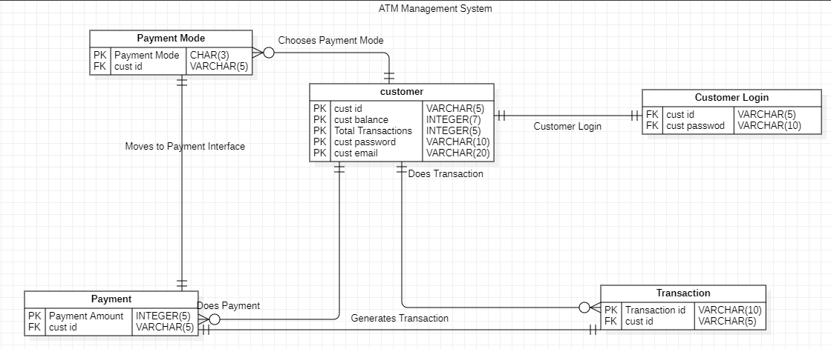

Data Flow Diagram:

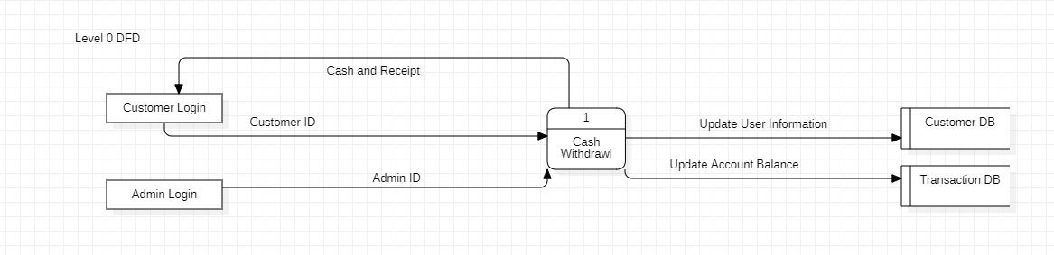

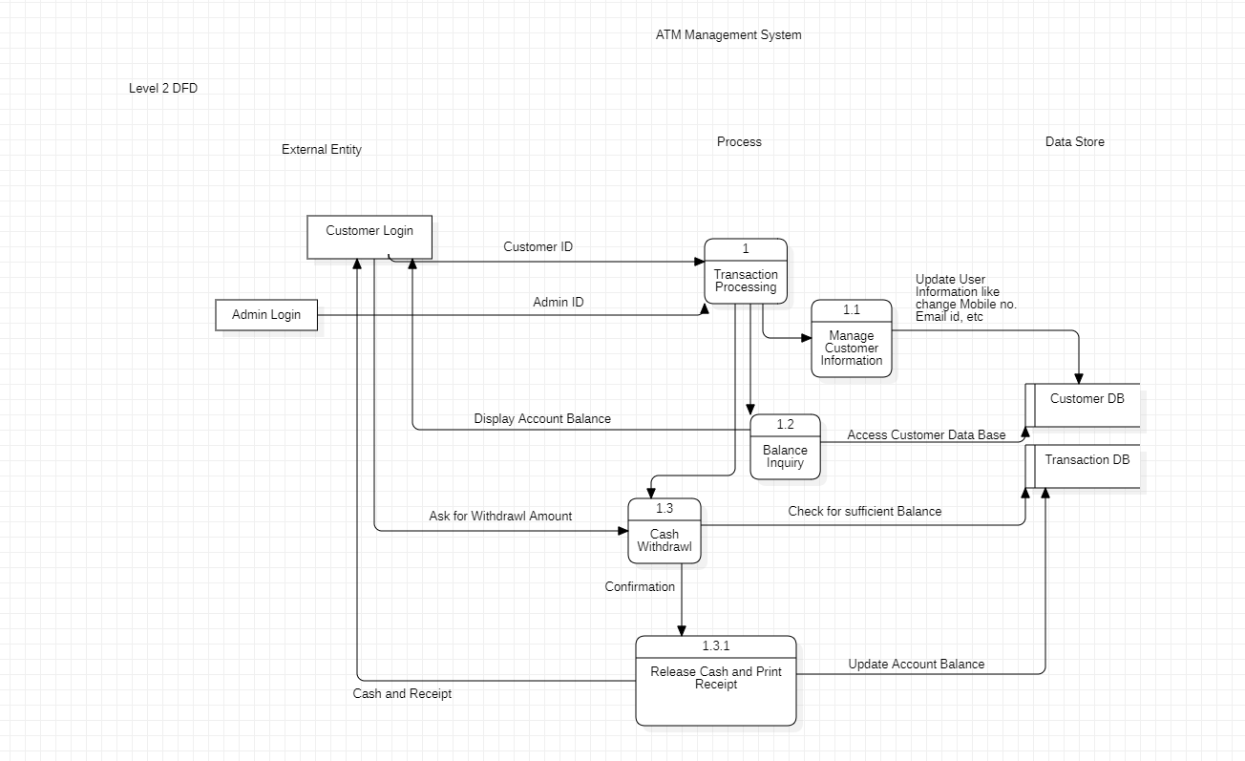

USE CASE Diagram:

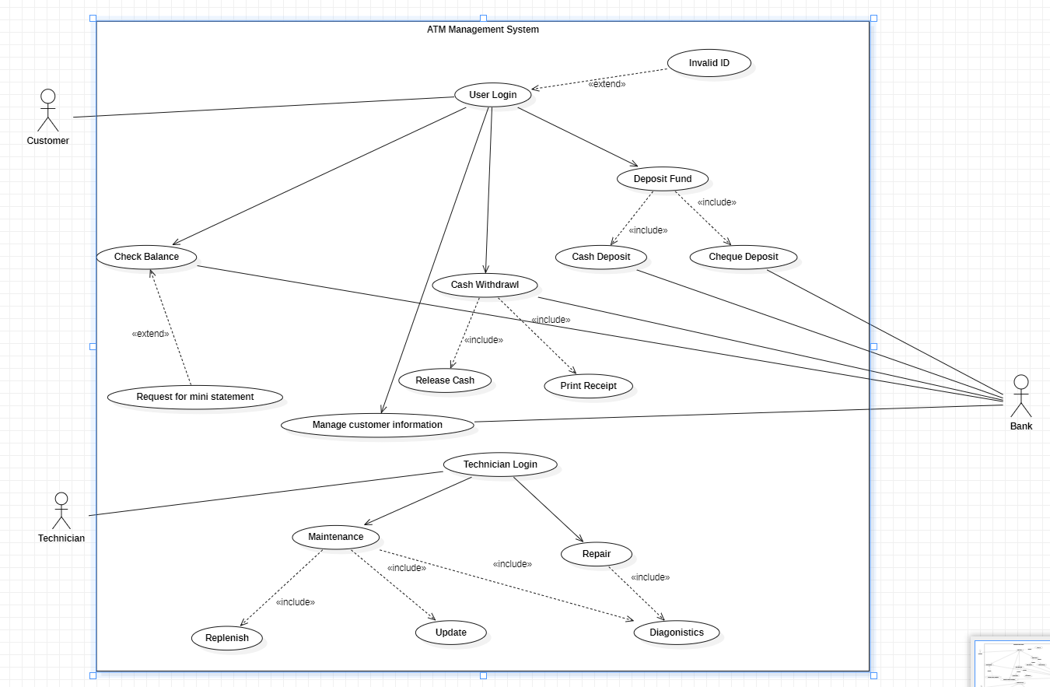

Appendix C: To Be Determined List

<Collect a numbered list of the TBD (to be determined) references that remain in the SRS so they can be tracked to closure.>